**Instagram User Analytics**

**Report**

* **Project Description**

In order to get business insights for the marketing, product, and development teams, we track how consumers connect with and interact with our digital product (software or mobile application).

Teams from throughout the company utilise these information to develop new marketing campaigns, choose which features to include in apps, gauge the performance of the apps by looking at user interaction, and generally improve the user experience while assisting in business expansion.

This project helps in the analysis of the raw data and metadata to produce insightful findings. It is possible to visualise and extract important insights using a variety of database management technologies. This makes it possible to improve a platform's efficiency.

* **Approach**

SQL was employed to carry out the job. With the provided raw data, a database was created using SQL queries. Many sorting and data extraction queries were used after the database was constructed to obtain the necessary data and insights.

* **Tech-Stack Used**

MySQL Workbench v8.0.32.0 was used during project execution in order to query the database. The ease of access and setup, troubleshooting support as well as the GUI made it a good tool for the project

* **Insights**

**Create a Database**

The very first step is Extract the data in the database for that the following commands were run for creating database to work on (the database has been provided by trainity). The entire analysis(or Task given on this project) is performed on SQL.

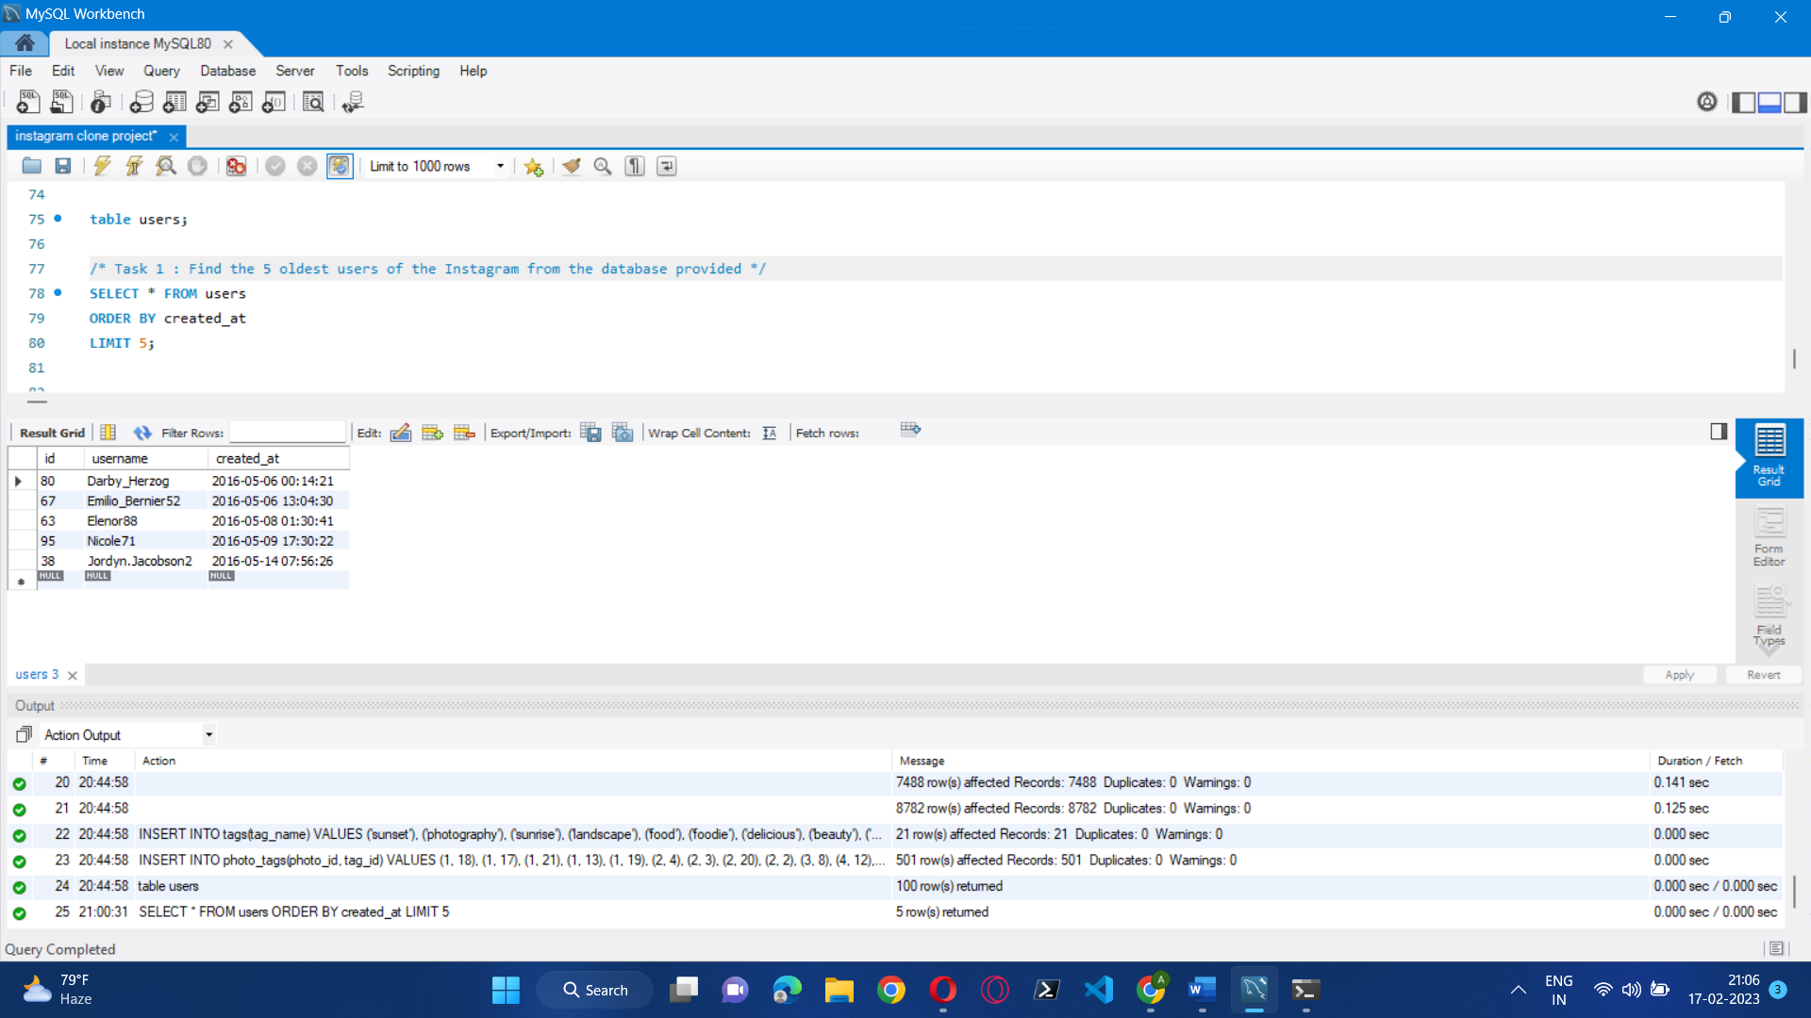

**Tasks: -**

* **By Marketing Team.**
* **Rewarding Most Loyal Users:**

People who have been using the platform for the longest time.

Your Task: Find the 5 oldest users of the Instagram from the database provided.

**Approach –** First step is to select data from database table(user) then we sort the data as per the account creation date (oldest to latest) and then picking up top 5 user data from sorted list.



* **Remind Inactive Users to Start Posting:**

By sending them promotional emails to post their 1st photo.  
Your Task: Find the users who have never posted a single photo on Instagram.

**Approach –** The first thing we can see that we want the name of the users where the condition is that the user has not post yet for that we need to connect the user data base table to photos table which is done by left joint and hence we will get the output as the username who have never posted a single photo on Instagram.

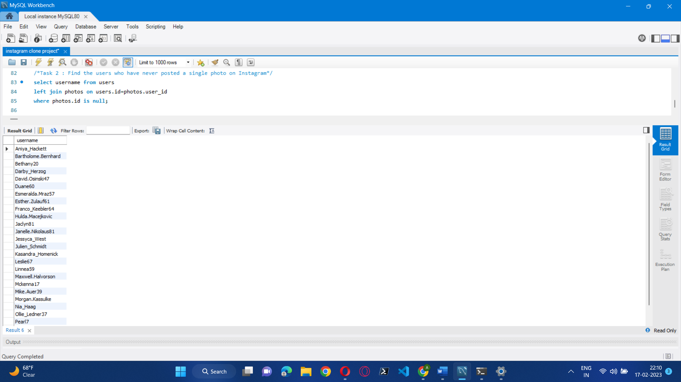

* **Declaring Contest Winner:**

The team started a contest and the user who gets the most likes on a single photo will win the contest now they wish to declare the winner.  
Your Task: Identify the winner of the contest and provide their details to the team.

**Approach –** For the following contest firstly we need to find what all information is required so selecting user name id, image URL , total likes count on particular photo. Then we see all these information is on different different table so we join those table user and photos table is join with like table as total no of likes on photo will win the contest. Next, we will be creating the group as per photos id and then order it by total no. of likes and then top 3 contestant are declared as the winner.

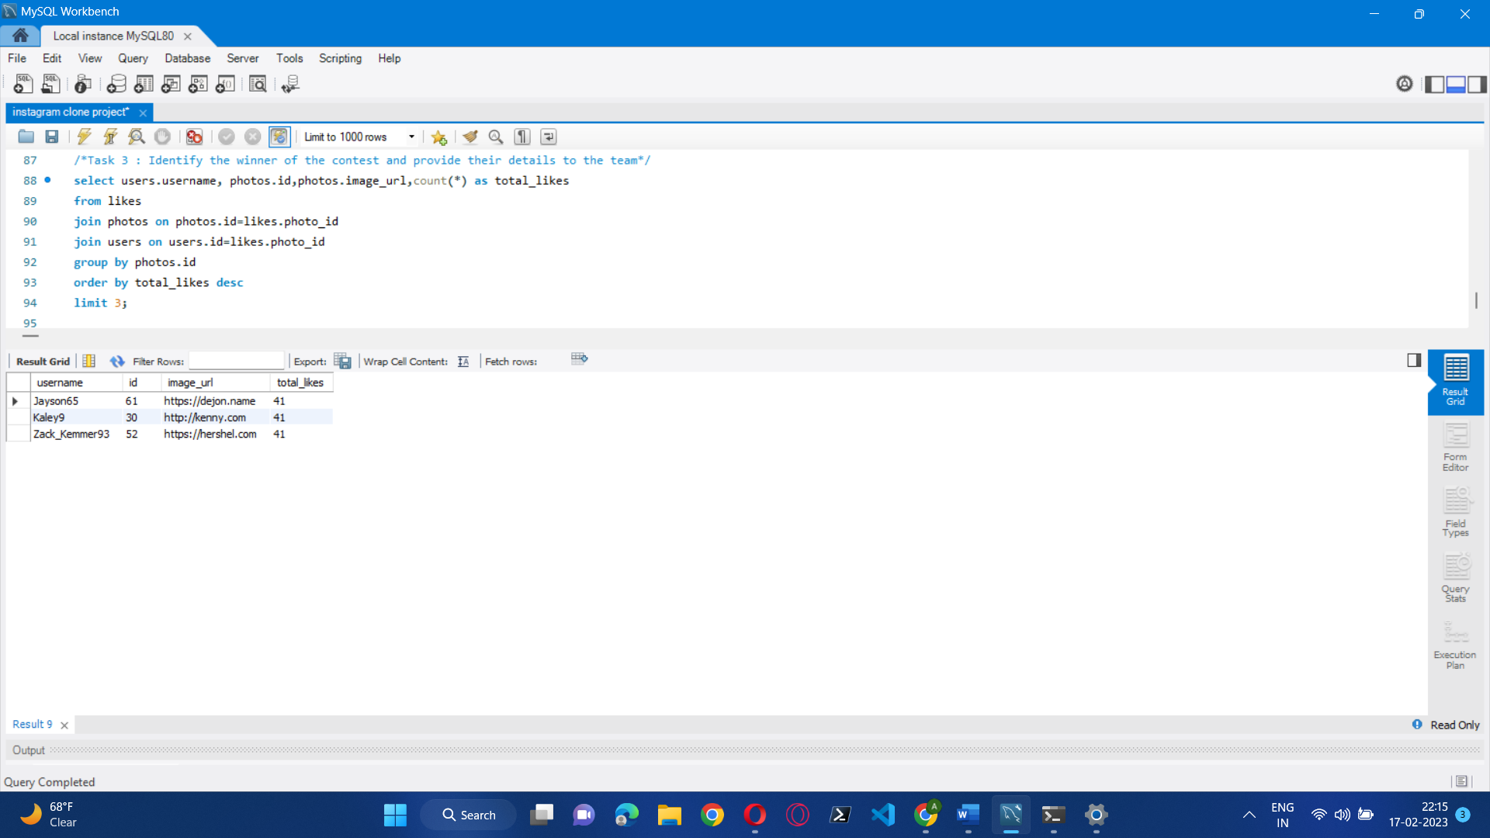

* **Hashtag Researching:**

A partner brand wants to know, which hashtags to use in the post to reach the most people on the platform.  
Your Task: Identify and suggest the top 5 most commonly used hashtags on the platform.

**Approach –** To identify the most used tags we need to select tag_name from tags table and apply count command so that we can get total no of times that particular tag is used on photos for that we need join tags table with photo_tags table and then group the tags.id and last order the Total (where total is the count of how many time the tag is used). Then the limit is there to get top 5 tags used.

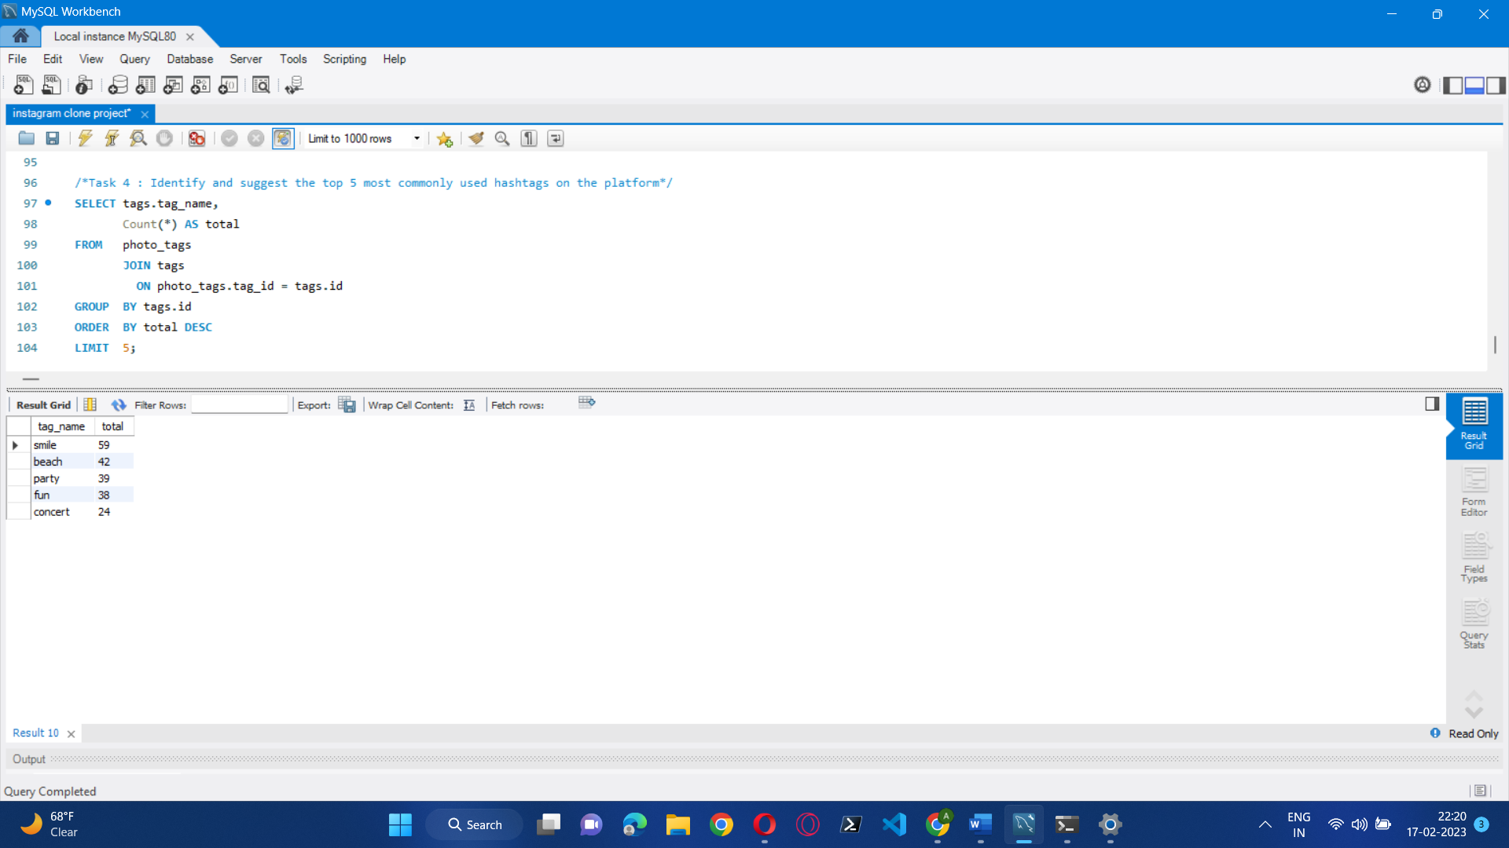

* **Launch AD Campaign:**

The team wants to know, which day would be the best day to launch ADs.  
Your Task: What day of the week do most users register on? Provide insights on when to schedule an ad campaign.

**Approach –** To identify the day on which most of the user register on Instagram for that firstly we need to select created_at and use command dayname to get day of creating account and then count the day . now from user table group the day data and then order to get the day at which most user register on Instagram.

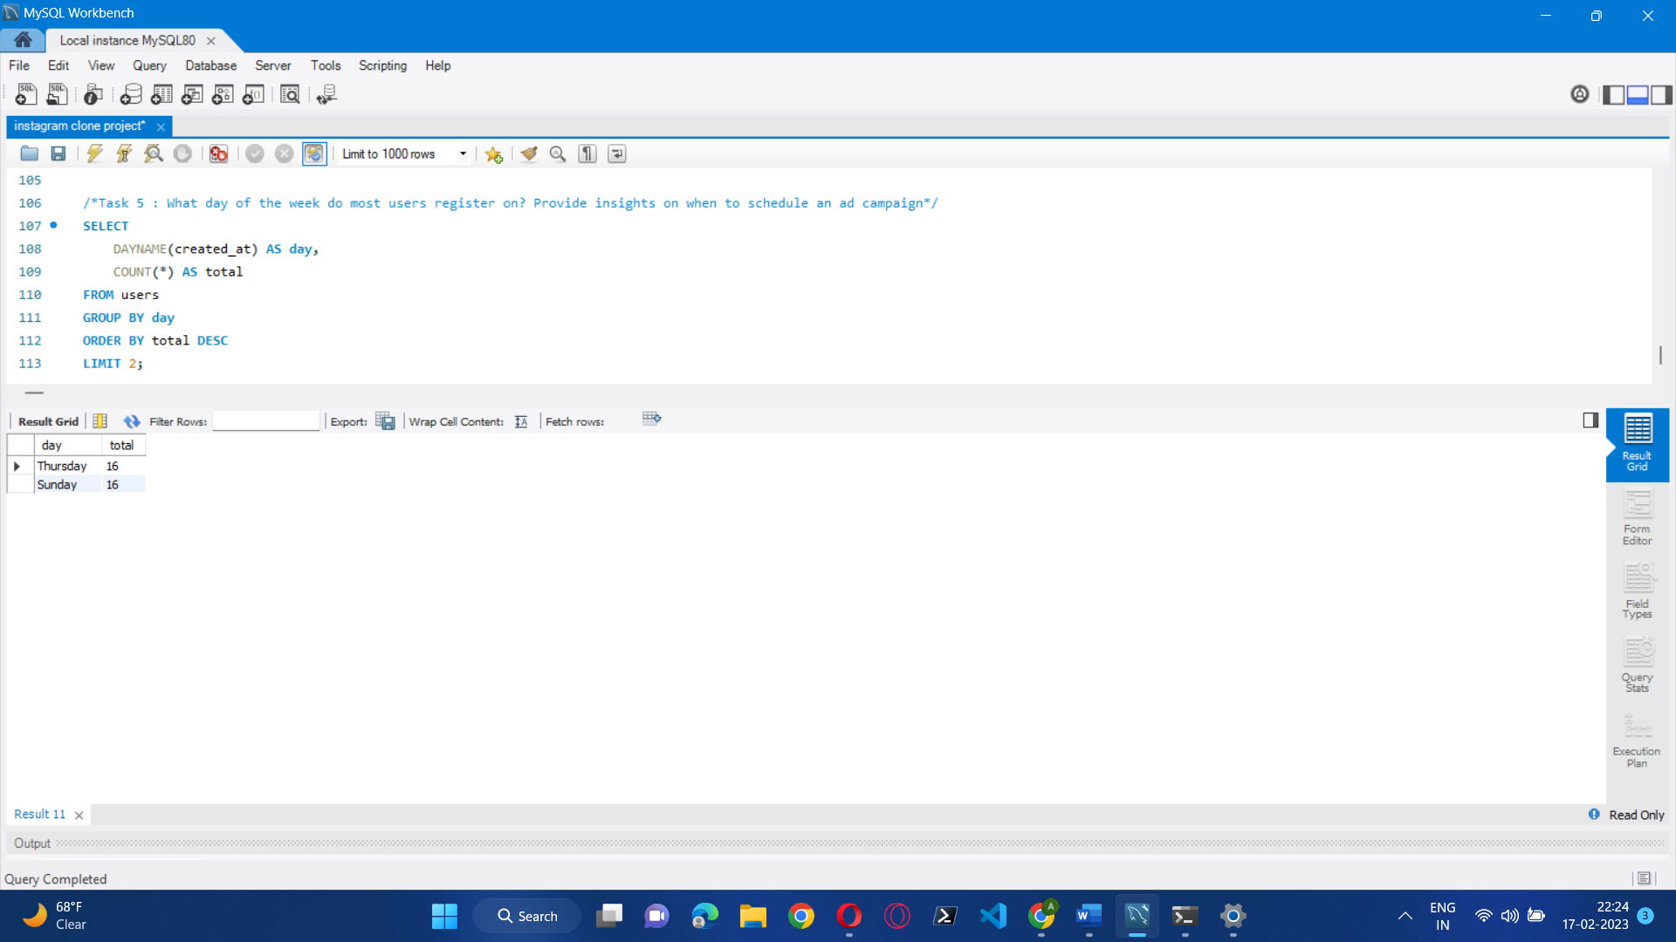

* **By Investor Metrics.**
* **User Engagement:**

Are users still as active and post on Instagram or they are making fewer posts  
Your Task: Provide how many times does average user posts on Instagram. Also, provide the total number of photos on Instagram/total number of users.

**Approach –** To get the average user post on Instagram it simply the total count of photos by total no of users so we apply count command to count it and hence the average is taken out.

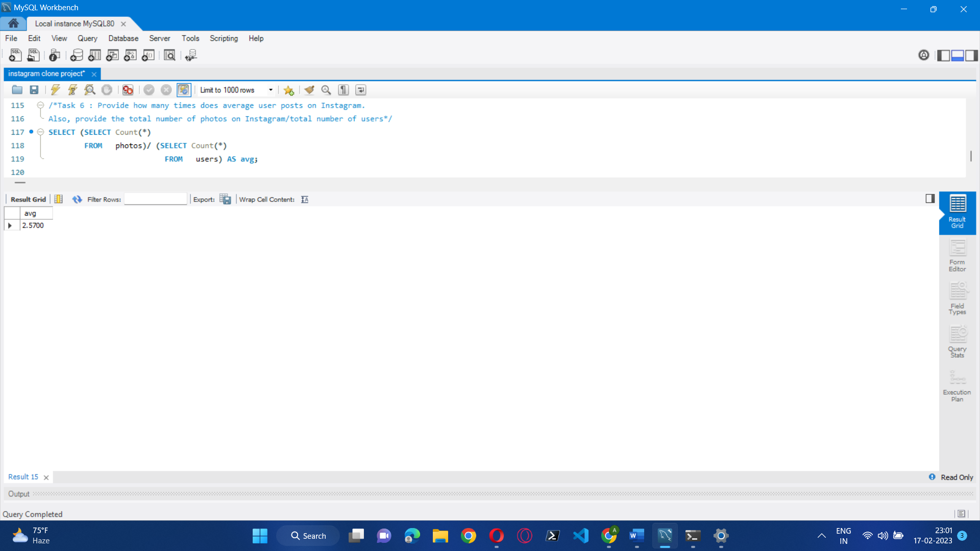

* **Bots & Fake Accounts:**

The investors want to know if the platform is crowded with fake and dummy accounts  
Your Task: Provide data on users (bots) who have liked every single photo on the site (since any normal user would not be able to do this).

**Approach –** To get the data of user(bots) who have liked every single photo on a site so basically the output is usernames who photos like count is equal to the total photos on site. To count the like count by user we apply inner joint on user table and like table where foreign key as id and the group the id and at last, we match the like count with the no. of photos on site.

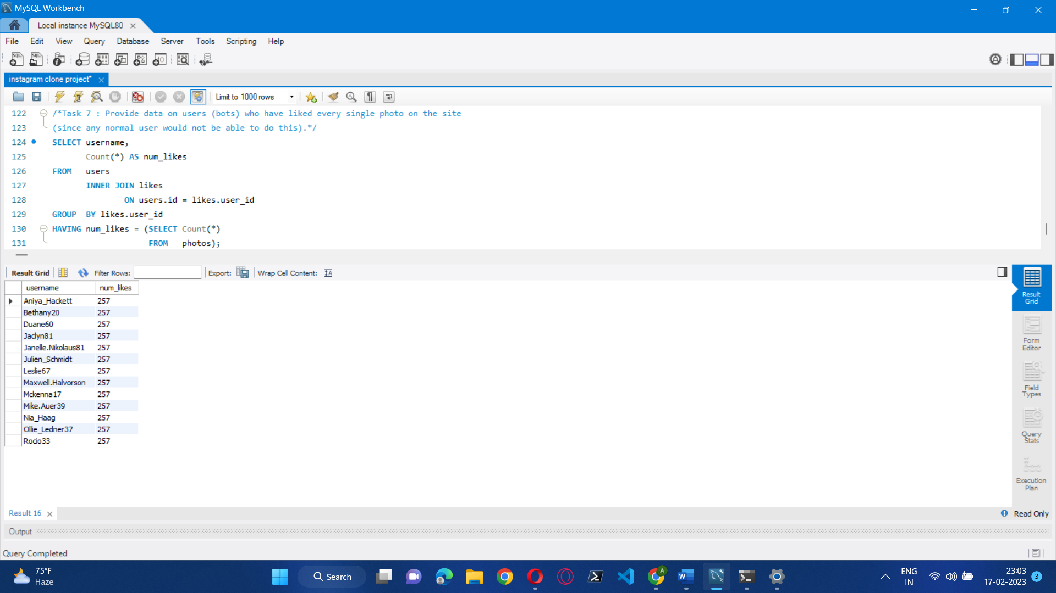

* **Result:**

In the project of Instagram user analytics, we've implemented the SQL query successfully to address the issue faced by the marketing team and investors, enabling them to work more efficiently on the website.